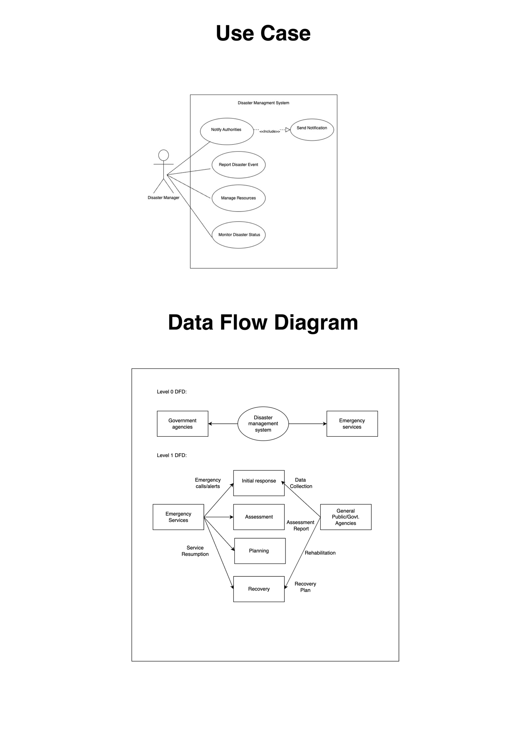

Functional Requirements:

1. Disaster Prediction: The system should be able to predict natural disasters such as earthquakes, hurricanes, floods, and wildfires accurately. The prediction should be based on machine learning algorithms that analyze historical data, current weather patterns, and other relevant factors.

2. Alert Notification: The system should send out real-time alerts to people in the affected areas through SMS, email, and social media platforms. The alerts should be customized according to the severity of the disaster, and the location of the user.

3. Emergency Response: The system should provide emergency response teams with accurate and up-to-date information about the disaster, including the location, intensity, and potential impact. This information will help responders to take appropriate measures and save lives.

4. Risk Assessment: The system should assess the risks associated with different types of disasters in different regions. This will help organizations and governments to plan and prepare for disasters, and allocate resources more effectively.

5. Resource Management: The system should help manage resources such as food, water, medicine, and shelter during and after a disaster. It should track the availability and distribution of resources, and identify areas where more support is needed.

Non-functional Requirements:

1. Performance: The system should be able to handle a large volume of data and process it quickly to provide real-time predictions and alerts.

2. Availability: The system should be available 24/7, and downtime should be minimized. The system should have a robust backup and recovery mechanism in place to ensure continuity of service.

3. Security: The system should be secure, with appropriate measures in place to protect user data and prevent unauthorized access. This is especially important given the sensitive nature of the data involved.

4. Scalability: The system should be scalable, and able to handle an increasing number of users and data volume over time. The system should be designed with modularity and extensibility in mind.

5. Usability: The system should be user-friendly, with a simple and intuitive interface that is easy to navigate. It should be accessible to users with different levels of technical expertise, including emergency responders, government officials, and the general public.